Lab Exercise 12 - Start and Access Kubernetes Dashboard
NAME : DIMPLE LULLA
SAP ID: 500120422
BATCH 2 DEVOPS

Objective
To enable Kubernetes in Docker Desktop, deploy the Kubernetes Dashboard, and access it securely using a web browser on Windows.

Prerequisites
- Windows 10 / 11
- Docker Desktop installed
- Docker Desktop Kubernetes enabled
- Internet connection
- kubectl (comes bundled with Docker Desktop)

Step 1: Enable Kubernetes in Docker Desktop
- Open Docker Desktop
- Go to Settings
- Select Kubernetes
- Check Enable Kubernetes
- Click Apply & Restart
Wait until Kubernetes status shows Running (green).

Step 2: Verify Kubernetes Cluster
Open PowerShell or Command Prompt and run:
- kubectl version --client
- Check cluster status:
- kubectl cluster-info
Check nodes:
kubectl get nodes
Expected output:
Node status should be Ready
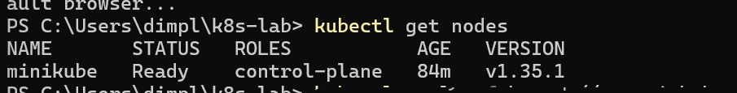

Step 3: Deploy Kubernetes Dashboard
Apply the official Kubernetes Dashboard manifest:

kubectl apply -f https://raw.githubusercontent.com/kubernetes/dashboard/v2.7.0/aio/deploy/recommended.yaml
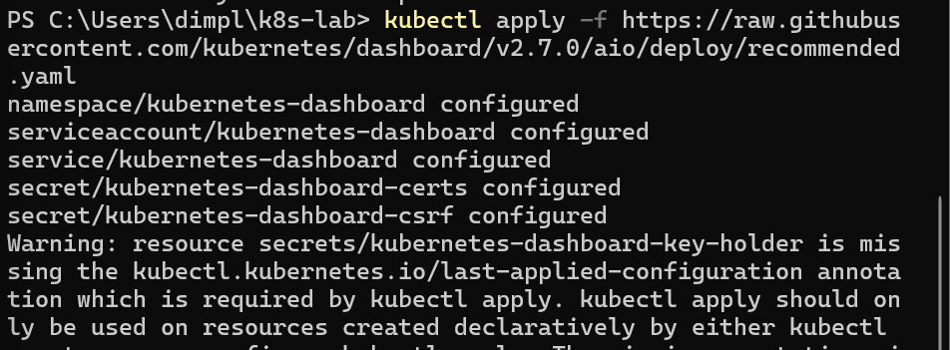
Verify namespace creation:
kubectl get ns
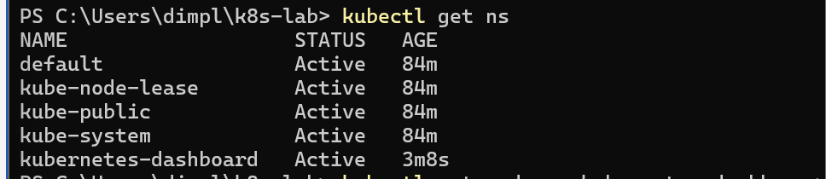
You should see:
kubernetes-dashboard

Step 4: Verify Dashboard Pods
Check dashboard pods:
kubectl get pods -n kubernetes-dashboard

Expected status:
Running
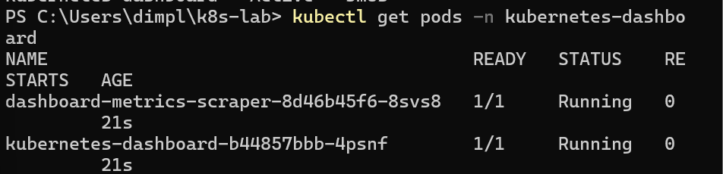

Step 5: Create Admin User for Dashboard Access
Create a service account:
kubectl create serviceaccount dashboard-admin -n kubernetes-dashboard
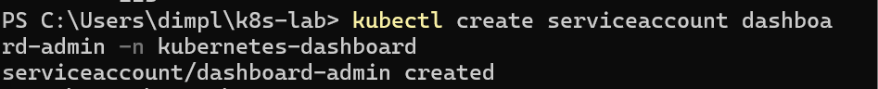
Create cluster role binding:
kubectl create clusterrolebinding dashboard-admin-binding --clusterrole=cluster-admin --serviceaccount=kubernetes-dashboard:dashboard-admin
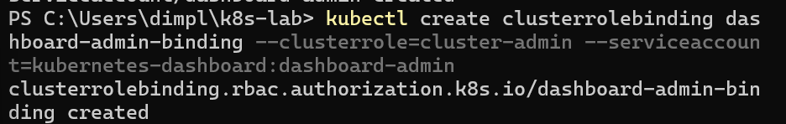

Step 6: Generate Dashboard Login Token
Run the following command to get the token:
kubectl -n kubernetes-dashboard create token dashboard-admin
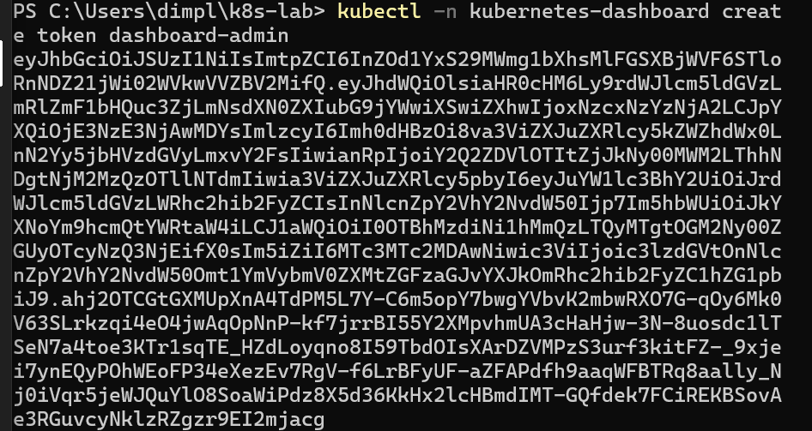
Copy the generated token (you will paste it in the browser later).

Step 7: Start Kubernetes Dashboard
Run the proxy command:
kubectl proxy
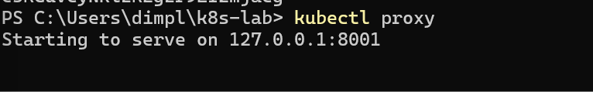
Keep this terminal running.

Step 8: Access Kubernetes Dashboard in Browser
Open a web browser and paste the following URL:
http://localhost:8001/api/v1/namespaces/kubernetes-dashboard/services/https:kubernetes-dashboard:/proxy/

Step 9: Login to Dashboard
- Select Token authentication
- Paste the token generated earlier
- Click Sign In
You should now see the Kubernetes Dashboard UI.
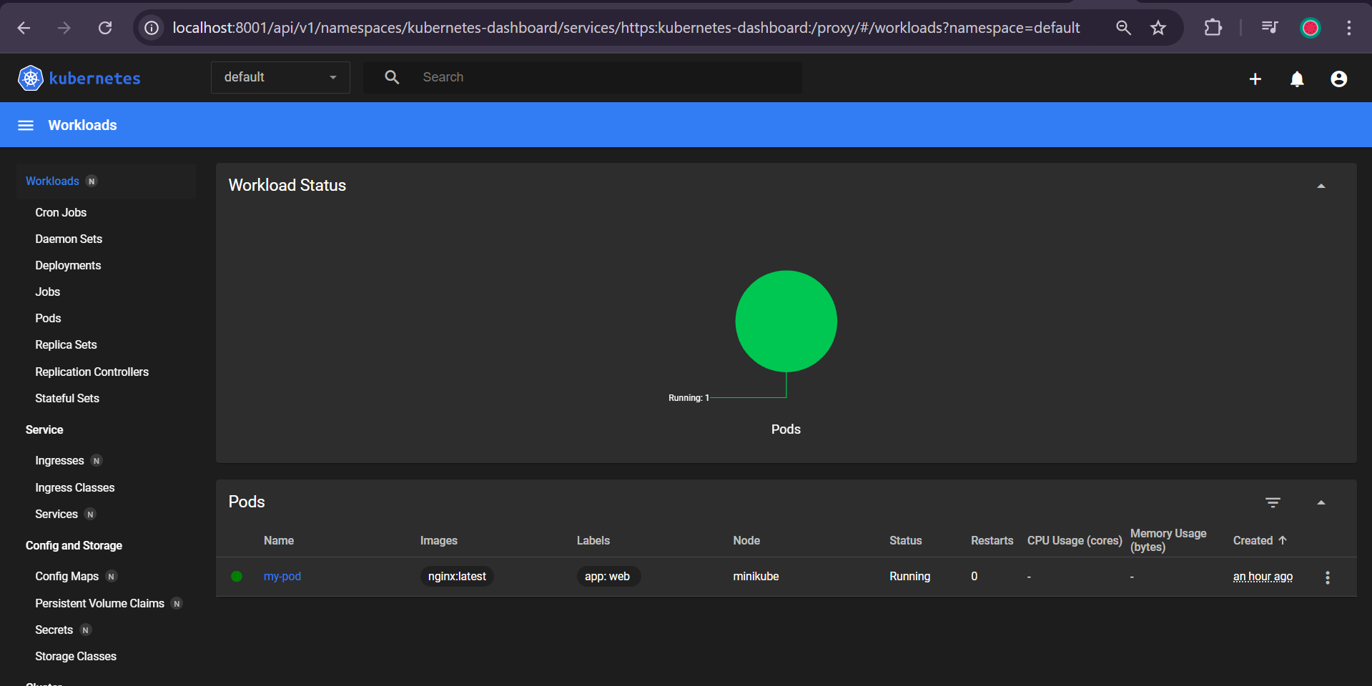

Step 10: Explore Dashboard
You can now view:
- Nodes
- Pods
- Deployments
- Services
- Namespaces
- ConfigMaps and Secrets
